Michael Chizy, Chairman  John L. Hebert, Vice Chairman  Richard Hersom, Clerk  Ryan Fattman  Kevin Geraghty  James A. Smith, Town Administrator | 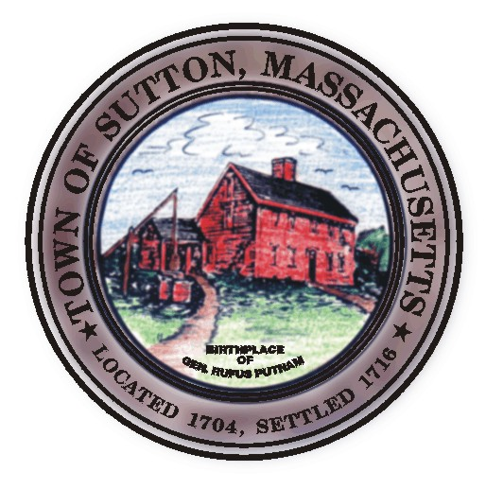 | Sutton Town Hall  4 Uxbridge Road  Sutton, Massachusetts 01590  (508) 865-8727  Fax: (508) 865-8721
Town Of Sutton
Board Of Selectmen

Meeting Agenda

7:00 p.m. – Tuesday, June 17, 2008

Sutton Town Hall, Selectmen’s Meeting Room

- Call to Order, Pledge of Allegiance at 7:00 p.m.

- Public Forum: Limited to 5 minutes per topic. Discussion or comments about town employees or agency members shall be avoided so as not to violate individual’s rights.

- Minutes
  - Board of Selectman minutes from 05/20/08
Board of Selectman minutes from 06/03/08
Executive Session minutes from 06/03/08

* Public Hearing *
2. Pole Hearing for Hartness Road (National Grid single pole hearing)

IV. Sponsored Agenda and Action Items
- Kettle & Kone Café: new owner, Michael Cassata Sr. requests Common Vic.
- Presentation of Marion’s Camp by Gates, Leighton & Associates, Inc.
- Inter-municipal Agreement for Sewerage between Millbury & Sutton
- Discussion of joint meeting with the BOS, School Committee and Finance
- Teamsters & Police Contracts

V. Town Administrator Update
VI. Announcements
VII. Selectman’s Roundtable: Correspondence and Business Topics

VIII. Executive Session

Adjournment

